* + **Project Title** 
    - **Plenty of Tiffs**
  + **Team Members**
    - **Casey Clingaman**
    - **Katie Forbush**
    - **Nursaid Saidmakhmudov**
    - **Stephen Cheng**
  + **Project Description**
    - **A platform for people who are disgruntled or have a bad day, so they can express their frustration with people who are just as pissed off as they are in their area.**
    - **They have to go on and enter their information (age, height, weight, or etc.). System will compare user information; put them into different categories and return several matches.**
    - **The app will take them to another windows, where they can send each other messages with selected GIPHY/Emoji.**
    - **If they are really piss off and want to have a flight, our server will send off a location for them to meet up. (Flight Date)**
  + **Sketch of Final Product**

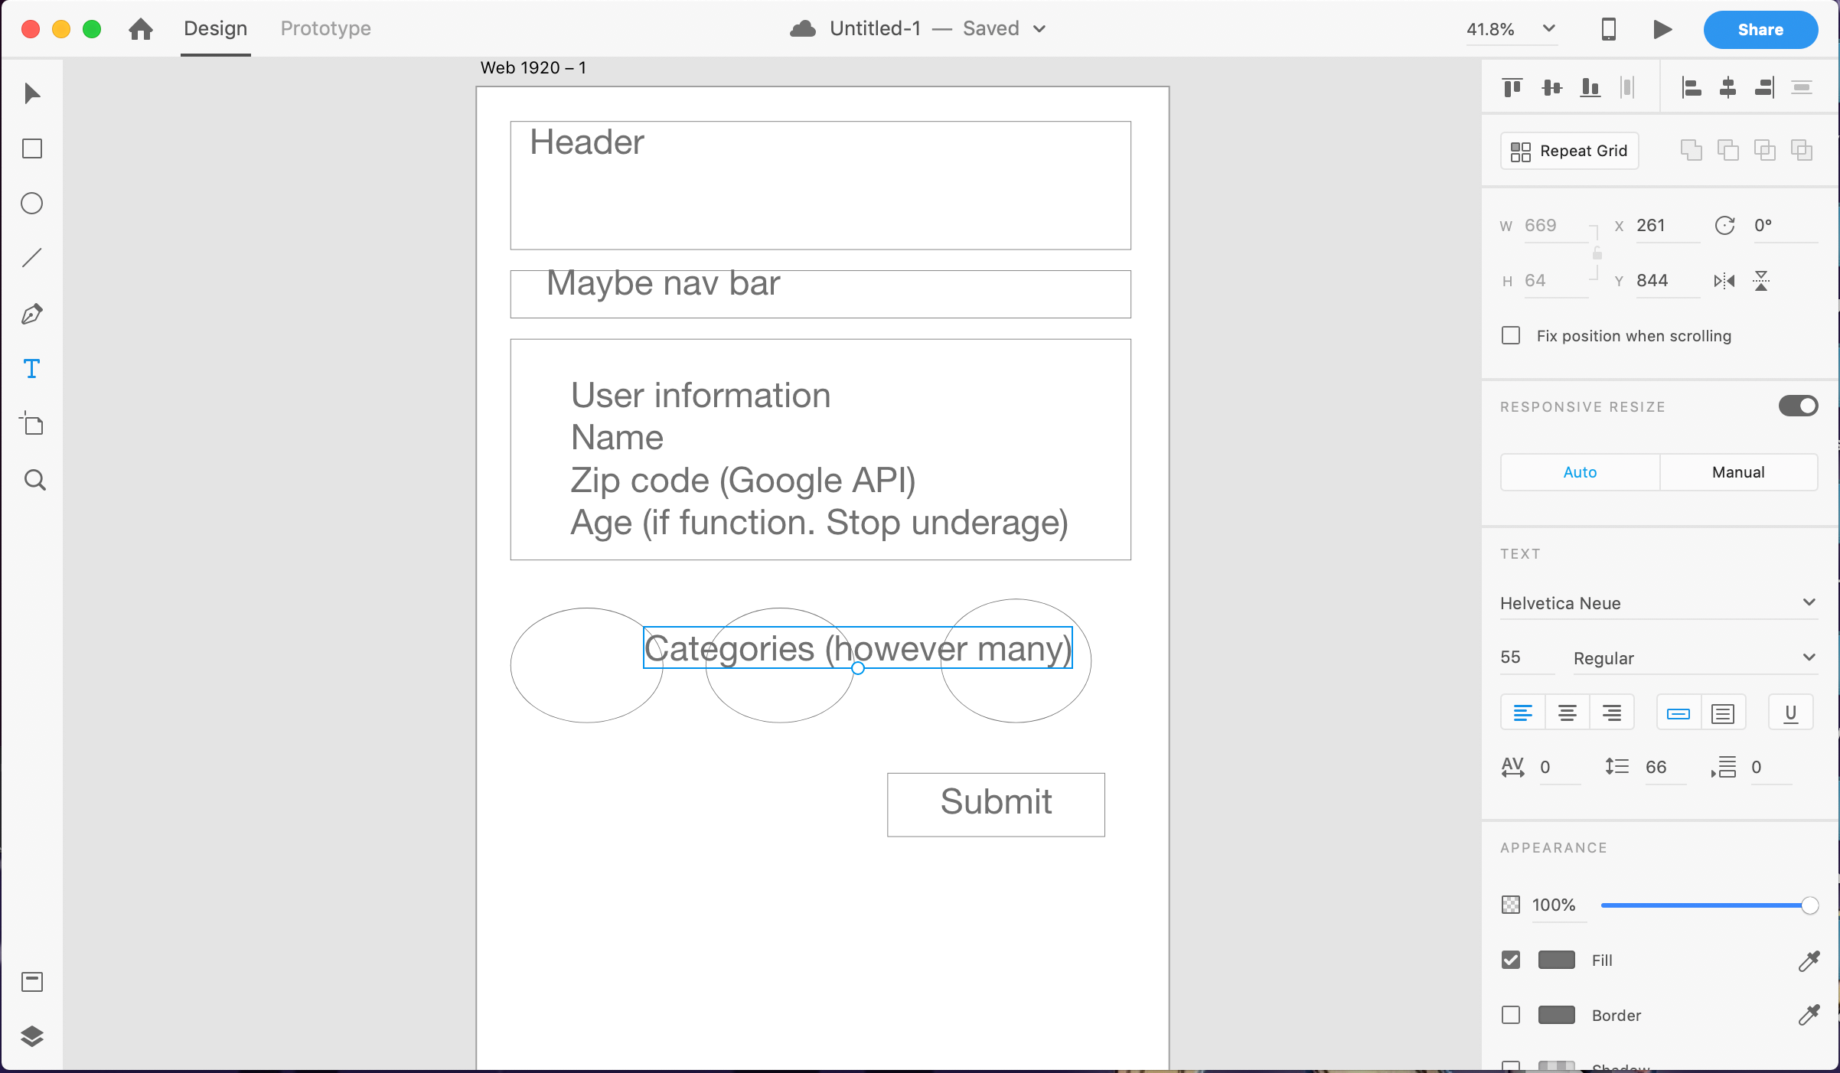

* + **APIs to be Used**
    - **Google Map API**
    - **GIPHY API**
    - **Emoji API**
    - **Facebook API (maybe)**
  + **Rough Breakdown of Tasks** 
    - **Katie – Project Manager**
    - **Said – API call**
    - **Casey – Design**
    - **Stephen – functionalities**